

**Faculty of engineering - Shoubra**

**Benha University**

**Research Article / Research Project / Literature Review**

in fulfillment of the requirements of

|  |  |
| --- | --- |
| **Department** | **Engineering Mathematics and Physics** |
| **Division** | **-----------** |
| **Academic Year** | **2019-2020 Preparatory** |
| **Course name** | **Computer** |
| **Course code** | **ECE001** |

**Title: -**

# Computer Architecture

By:

|  |  |  |  |
| --- | --- | --- | --- |
|  | Name | Edu mail | B.N |
| 1 | محمد عبدالناصر السيد همام | muhammed195848@feng.bu.edu.eg | 759 |

**Approved by:**

|  |  |
| --- | --- |
| Examiners committee | Signature |
| Dr.Ahmed Bayoumi |  |
| Dr.Shady Elmashad |  |
| Dr. Abdelhamid Attaby |  |
|  | |

# Research objectives

* [Computer](https://mohamed-abodouh.github.io/ece001/Computer.html)
* [Input and Output Devices](https://mohamed-abodouh.github.io/ece001/Input%20and%20Output%20Devices.html)
* [Motherboard and CPU](https://mohamed-abodouh.github.io/ece001/Motherboard%20and%20CPU.html)
* [Port](https://mohamed-abodouh.github.io/ece001/Port.html)
* [Machine Cycle](https://mohamed-abodouh.github.io/ece001/Machine%20Cycle.html)
* [Memory Vs. Storage](https://mohamed-abodouh.github.io/ece001/Memory%20Vs.%20Storage.html)
* [Types Of Computers](https://mohamed-abodouh.github.io/ece001/Types%20Of%20Computers.html)
* [Ergonomics](https://mohamed-abodouh.github.io/ece001/Ergonomics.html)

Website Link: <https://mohamed-abodouh.github.io/ece001/>

GitHub Pages Link: <https://github.com/Mohamed-Abodouh/ece001>

# Introduction

The computer lies at the heart of computing. Without it most of the computing disciplines today would be a branch of theoretical mathematics. A professional in any field of computing should not regard the computer as just a black box that executes programs by magic. We should acquire some understanding and appreciation of a computer system’s functional components, their characteristics, their performance, and their interactions. We need to understand computer architecture in order to make best use of the software tools and computer languages we use to create programs.

# A Short Brief about the Website

The Website contains a Main Page and Nine Pages attached to it. The Main Page consists of Nine Elements. When we press on any Element, The Website goes to another page which views this Element and after reading all the Element Information, we will find a button called "Go To Main Page".When we press on it, the Website returns back to Main Page.

The Website is talking about Computer Architecture and its Elements such as: Computer, Input and Output Devices, Motherboard and CPU, Port, Machine Cycle, Memory Vs. Storage, Types of Computers, Ergonomics and finally the References used to collect Information about this Article.

We will find the References, the last Element in the Main Page, when we press on it, the Main Page goes to another Page which views the References.

The Website contains 35 Pictures for these Elements and many Lists and Tables with all their Types.

The website contains different shapes of arrows used to point to Information.

Each Element contains the most important Information about it.

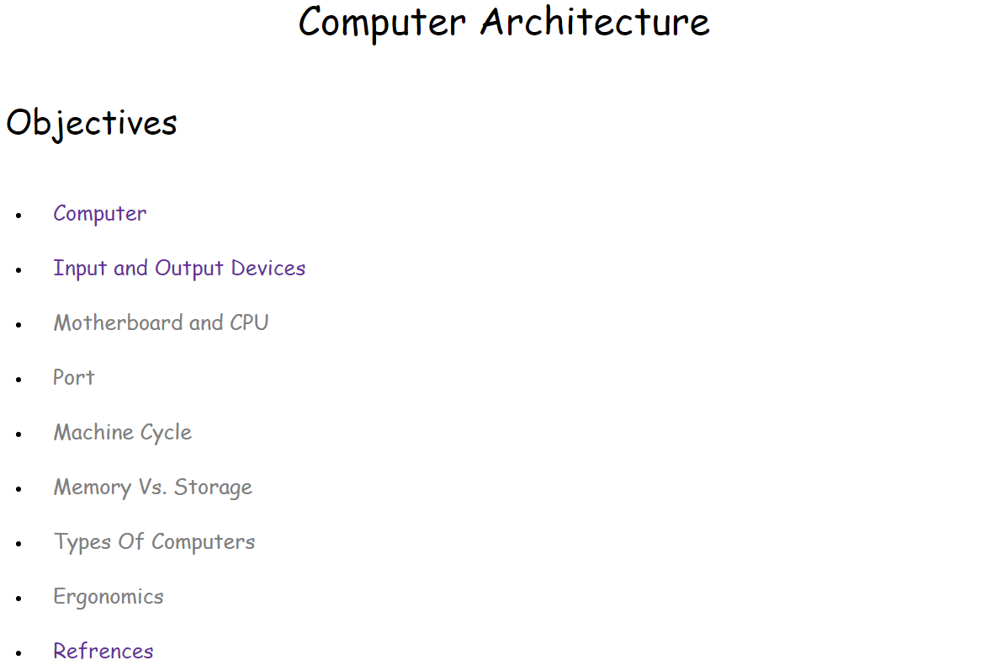

When we press on the first element (computer).

Main page.

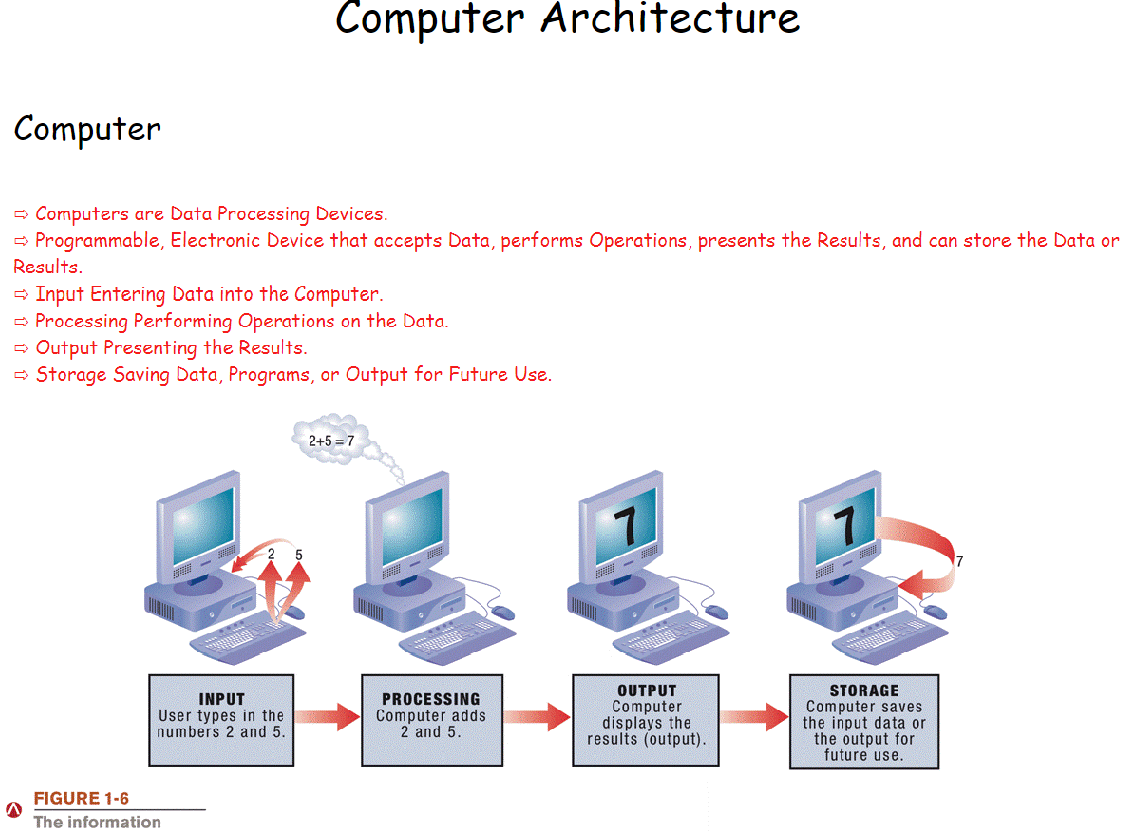

After seeing the whole data press on (Go To Main Page).

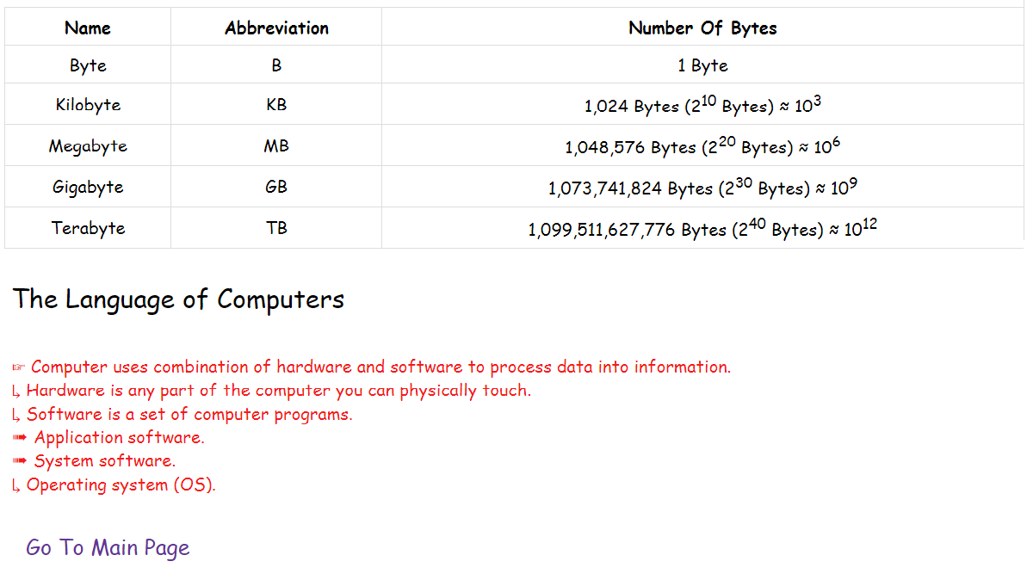

Main Page appears again.



You can choose another Element such as (Types Of Computers).

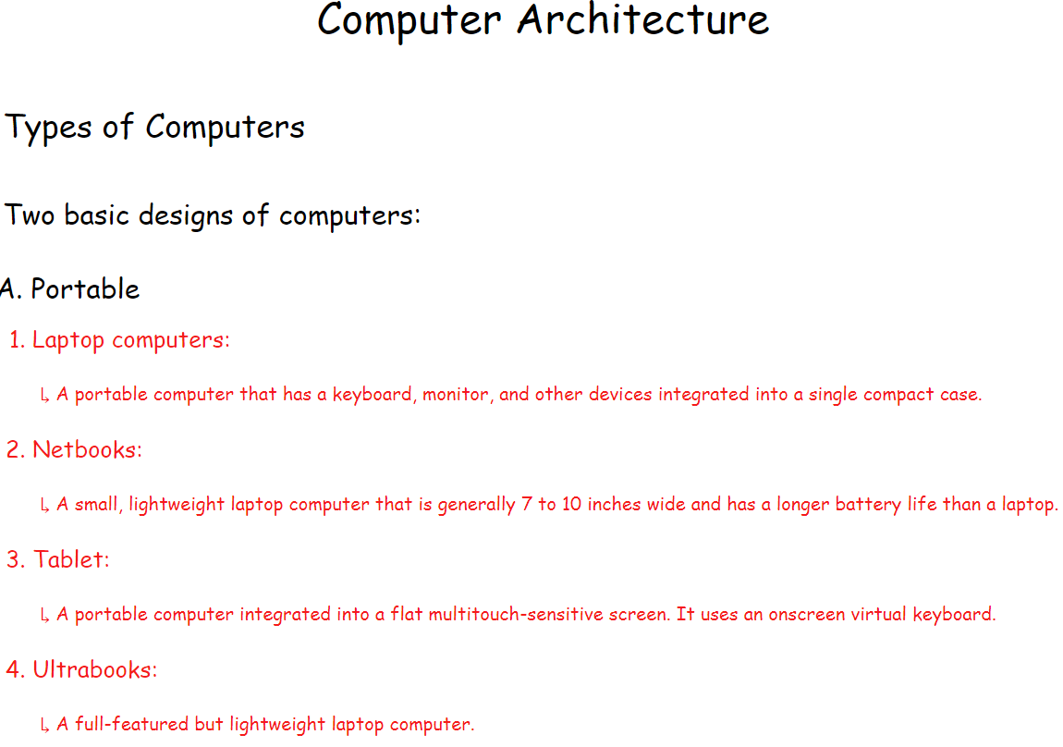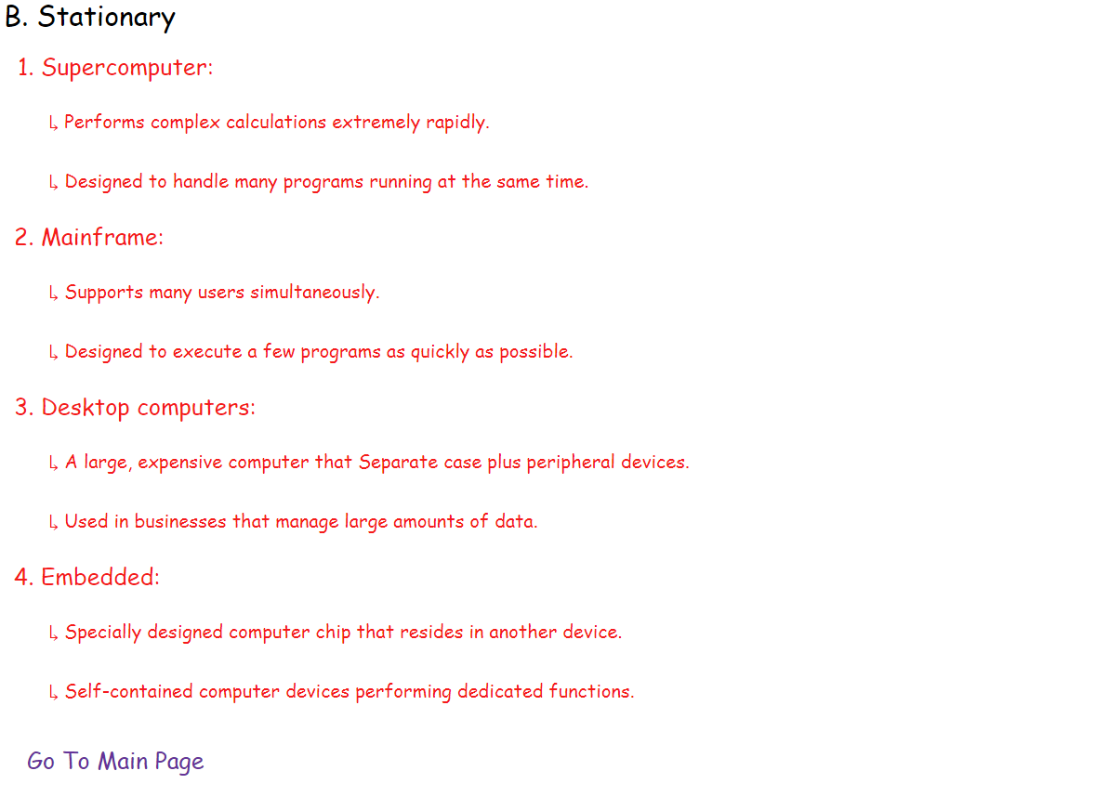

After seeing the whole data press on (Go To Main Page).

Main Page appears again.



You can choose another Element such as (Refrences).



